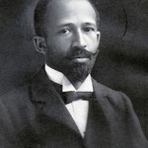

🙞 🙜

### **Scholarships**

🙞 🙜

The English Department at UMBC is a vibrant center for research, teaching, and learning.

We offer a **Master of Arts in Texts, Technologies** **and Literature** as well as two undergraduate major tracks: the **Communication and Technology Track**, for written and spoken communication and the new information technologies; and the **Literature Track**, for the broad range of diverse traditions of literature written in English.

The Department is also home of UMBC’s innovative First-Year Composition Program.

English Department

University of Maryland, Baltimore County

423 Performing Arts & Humanities

1000 Hilltop Circle

Baltimore, MD 21250

410.455.2384

Front Desk Hours:

8:30 AM – 4:30 PM

Monday through Friday

UMBC

ENGLISH

DEPARTMENT

**The Barksdale Scholarship** was established to pay tribute to Richard K. Barksdale, the second African American to receive a Ph.D. in English literature from Harvard University.

Recipients of this scholarship will be UMBC English majors who have at least a 3.2 GPA and have demonstrated a commitment to the advancement of minorities in the field of English.

The Barksdale Scholarship will consist of $500 per semester in tuition support for one academic year. If the candidate is already fully supported, the award will be $500 in cash as well as institutional recommendation for graduate study.

**The Ford Scholarship** was established in memory of Nick Ford and as a tribute to Ola Ford. Professor Ford received his Ph.D. in English from the University of Iowa and served for many years as Chair of the English Department at Morgan State University.

This scholarship will be awarded to an outstanding African American English major at UMBC with at least a 3.2 GPA who is planning graduate study in English.

The Ford Scholarship consists of $500 per semester in tuition support for one academic year. If the candidate is already fully supported, the award will be $500 in cash as well as institutional recommendation for graduate study.

🙞 🙜

Applications should be submitted to the Chair of the English Department by December 1.

Students who meet the eligibility requirements for The Barksdale Scholarship and The Ford Scholarship are welcome to apply for both.

For more information or a copy of the application, please drop by the front office of UMBC’s English Department.

🙞 🙜

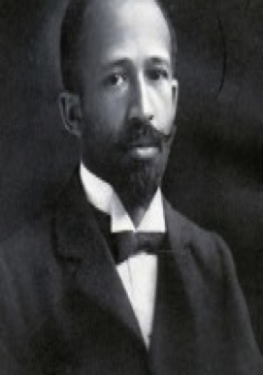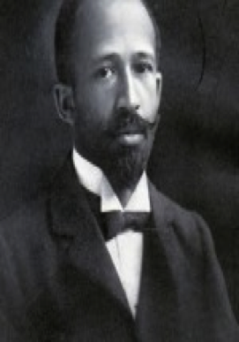

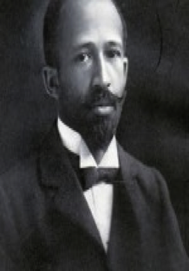

# Scholarships



 

 